Please use style “Heading”
A BC*^{,1}, Bobby Goodtimes², Johnny Bandana^{1,2} (Style “Authors Cavtat”)
¹ Department of Chemical and Biomolecular Engineering, National University of Singapore, Singapore
*E-mail: xx@yy.zz (address and email style “Address Cavtat”)

Abstract
We strongly encourage using the Style “Abstract Cavtat” from Word’s style menu. This would help us tremendously to seamlessly prepare the abstract book.
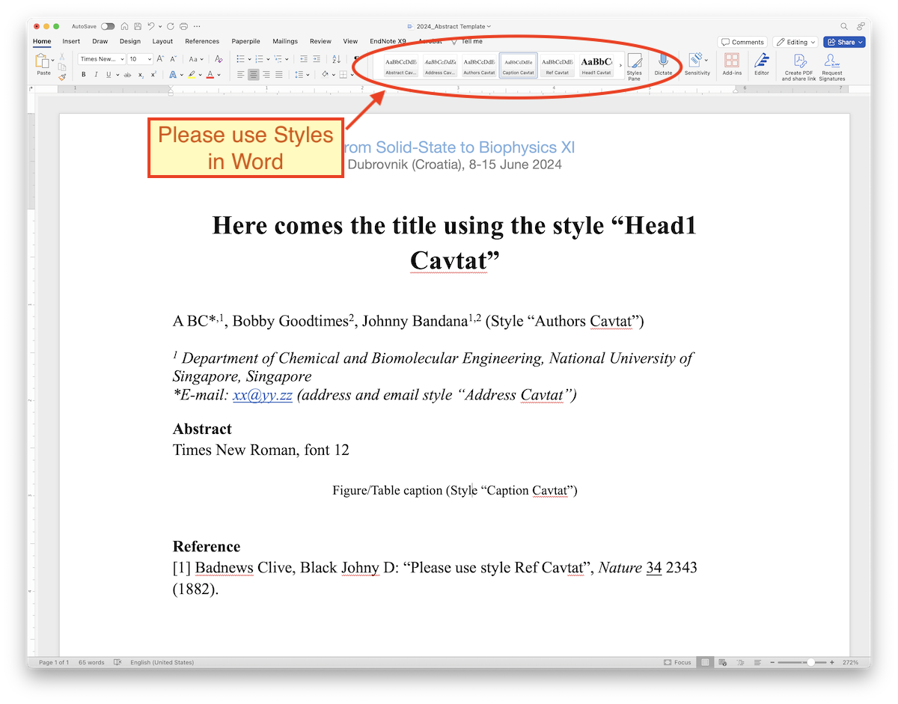
Optional Figure 1. This is Figure/Table caption (Style “Caption Cavtat”). The Style menu is on top.

References
[1] Badnews Clive, Black Johny D: “Please use style Ref Cavtat”, Nature 34 2343 (1882).

Please indicate your planned dates of stay:
[ ] Whole conference (majority of participants)
[ ] From DD-MM to DD-MM

Additional Note (Optional):

